Neural Networks and Categorization Problems

Something to Consider
Many times in life we lump things into categories based on their characteristics. For example there are many types of apples which are different in some ways but share some fundamental characteristics which put them into the category apples. This may seems like a silly way to think about things but perhaps people take for granted their innate ability to look at something like an apple, or a cell phone or anything and know what it is. Consider the difficulty of describing an apple. For that matter how would you describe an apple and a pear in such a way that some one who has never seen either could discern between the two. And does it seem possible that a machine would ever be able to make such a discrete distinction.

However useful it would be to make a machine able to tell the difference between apples and pears that is way outside of my scope. In lieu an easier and simpler form of this problem, the problem of teaching a machine to recognize categories based on parameters, seems like an appropriate undertaking for a semester long project on neural networks. The examples which are considered in this paper are much simpler than the categorization problems which might have real applications, but do not discount the usefulness of considering such simple examples. Hopefully, these will give insights into the nature of the problem and thereby aid in understanding more complicated applications.

What is a Categorization Problem?

- A categorization is an association of subsets of a space S to elements of another space C . Each subset is associated with a unique element of C.
- A separation map transforms from S onto C according to the categorization
- Problem: train a neural network to approximate the separation map.

Experimental Examples

One of the main goals of this project is to be able to understand the separation capabilities of particular types of networks. Unfortunately one semester is not a long time. The following examples are only of feed-forward neural networks with one hidden layer. In every example the space S is the zero to one square in the real-two-space. The first three examples are all concerning the effect of increasing the number of intermediate nodes on the separation capabilities of the network. And what effect the geometry of the subsets has on the difficulty of the separation. The fourth example is an examination of the effect of introducing nonlinearities into the input data – in this case using the input variable on their squared values for prediction. The fifth example is a survey of various separation problems.

The Neural Network Architecture for Examples One, Two and Three
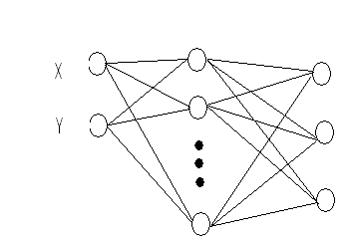

The transfer function used for every node in every example is zero-one sigmoid.

Example One

In this example the input data for the network are the x and y coordinates of the training point. The key point of this example is that increasing the number of intermediate nodes increases the ability of the network to deal with curved boundaries. Notice how the fit to the boundaries is better and better as the number of nodes increases. The only exception is going from two intermediate nodes to three intermediate nodes. However this was because back-propagation got stuck at a suboptimal solution which; and as you can see later the three layer network was an improvement if the networks weights are initialized at a ‘good’ start. Later in the paper the issue of a good start will be addressed. The important thing to recognize is that back-propagation is limited in taking full advantage of the separation capabilities of any particular network because it is steepest-descent based optimization algorithm.

Something interesting to notice is that when there are only two intermediate nodes, the network basically ‘draws’ two boundaries across the space. However for the three intermediate nodes network with a good start it appears that at least four lines have been drawn across the space; are they even lines (hard to tell)?

Training Set

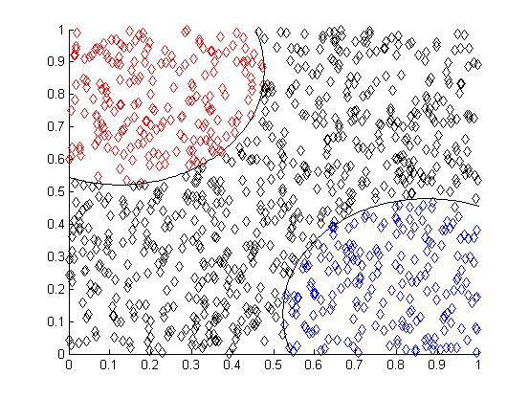

Two Intermediate Nodes

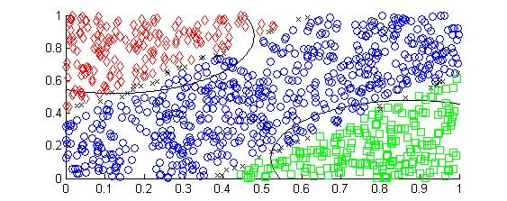
Three Intermediate Nodes
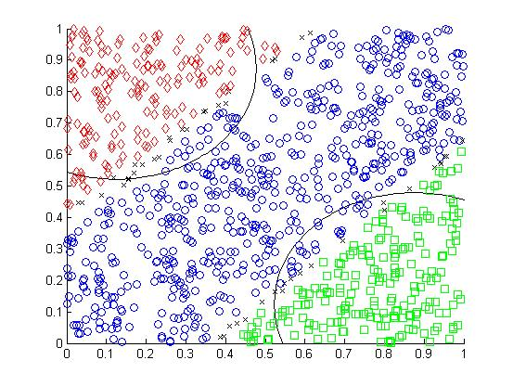

Four Intermediate Nodes
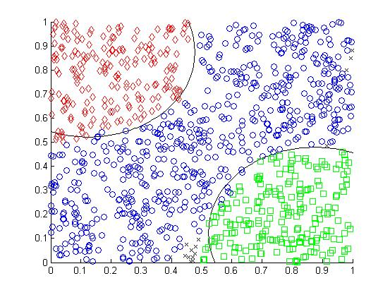

Five Intermediate Nodes
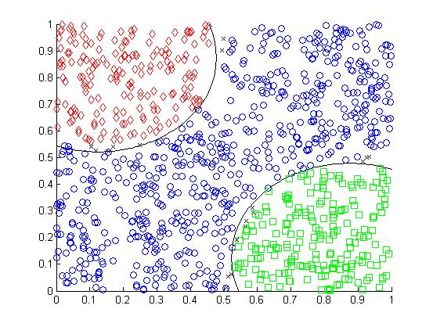

Eight Intermediate Nodes
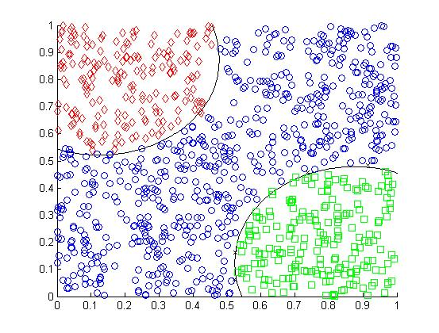

Three Intermediate Nodes – Good Start
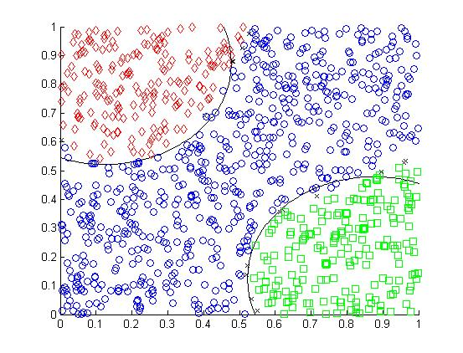

Summary Data

Intermediate Nodes | 2 | 3 | 4 | 5 | 8 | 3 Good Start
Error 100,000 Iterations | 12.7034 | 12.9837 | 7.8815 | 6.5509 | 4.9156 | 8.6136
Error Million Iterations | 12.0145 | 12.0657 | 6.292 | 5.3418 | 3.257 | 6.1972
Points Wrong | 95 | 88 | 21 | 3 | 8 | 19
Points Uncategorized | 31 | 49 | 15 | 18 | 4 | 16

Example Two

This example is very much like example one. The main difference is that two of the subsets are now completely surrounded by the third subset. Notice that it takes nine intermediate nodes (without a good start) before the network is able to describe the separation whereas before it really one took three.

Training Set
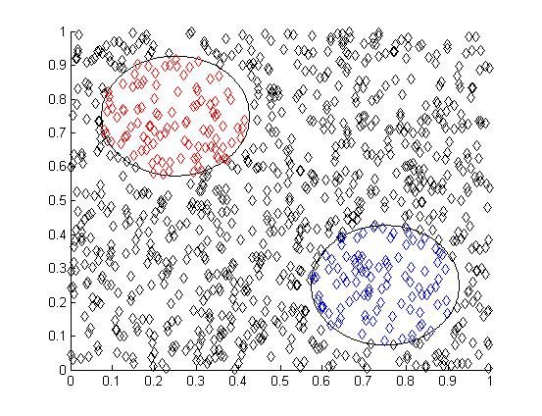
Two Intermediate Nodes
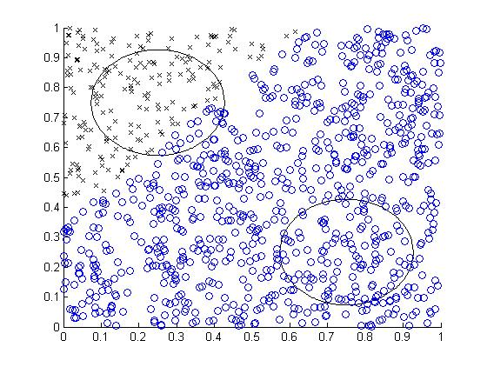
Three Intermediate Nodes
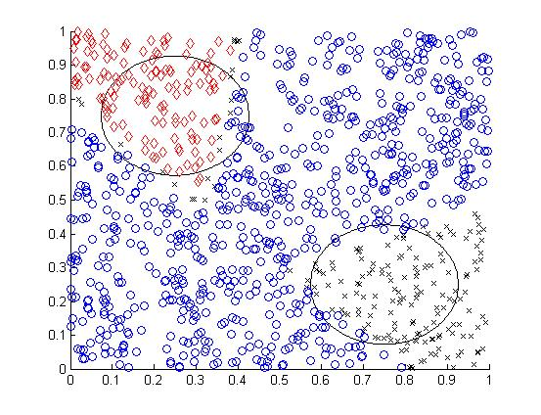

Six Intermediate Nodes
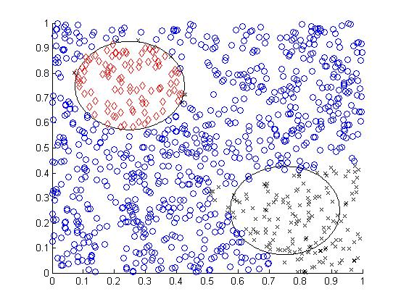
Nine Intermediate Nodes
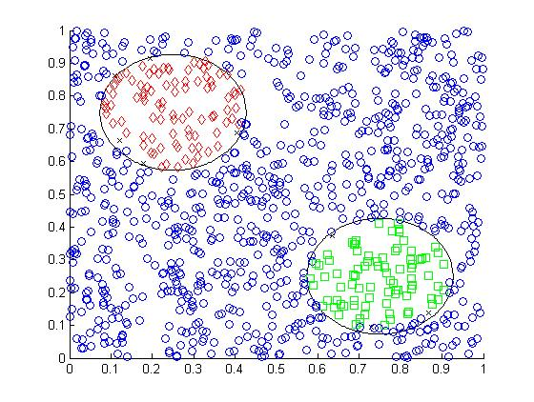
Twelve Intermediate Nodes
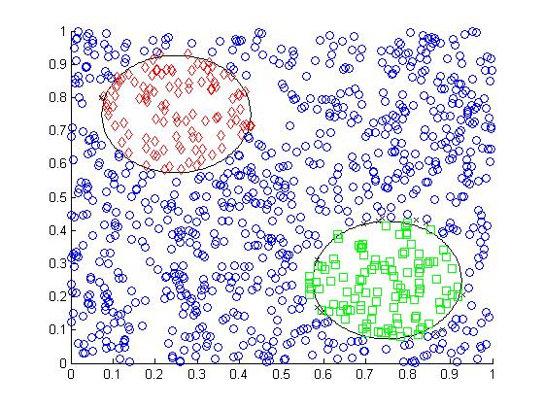

Summary Data
Intermediate Nodes | 2 | 3 | 6 | 9 | 12
Error 100,000 Iterations | 16.0542 | 141,645 | 11.9779 | 11.5367 | 10.7949
Error Million Iterations | 16.0647 | 13.8064 | 10.0904 | 5.5746 | 4.8995
Points Wrong | 117 | 68 | 7 | 15 | 16
Points Uncatagorized | 197 | 177 | 171 | 8 | 13

Example Three

Now the two subsets are touching in the center of the space. One important thing to notice about this example is that the network with nine nodes has slightly more error than the twelve nodes network however the pictures reveal that the twelve nodes network was not able to categorize points near the point where the two category subsets touch. This is evidence that back-propagation did not use the full potential of the twelve intermediate node network and also subsets which touch in the space are generally difficult for back-propagation trained networks to separate.

Training Set
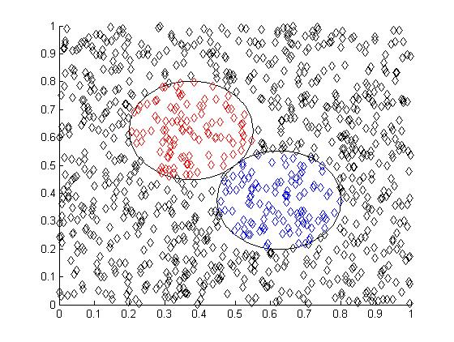

Two Intermediate Nodes
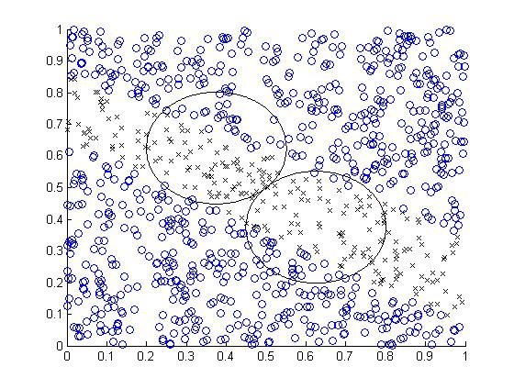
Three Intermediate Nodes
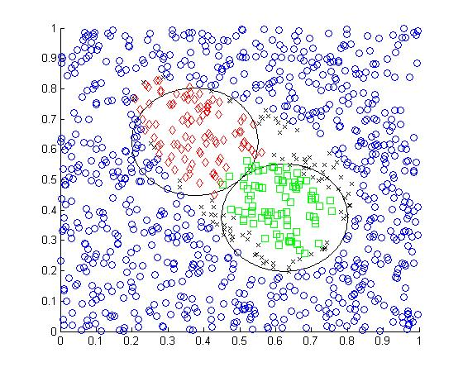
Six Intermediate Nodes
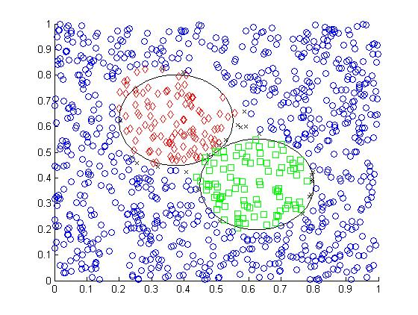
Nine Intermediate Nodes
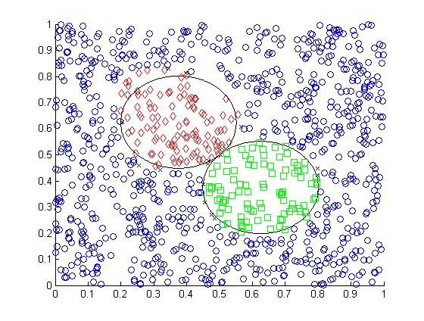
Twelve Intermediate Nodes
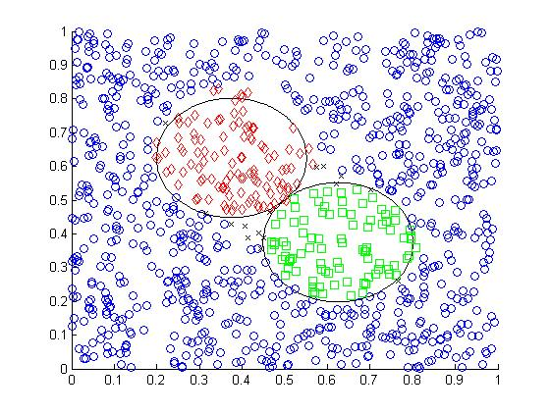

Summary Data
Intermediate Nodes | 2 | 3 | 6 | 9 | 12
Error 100,000 Iterations | 16.4712 | 11.2403 | 7.0033 | 7.7878 | 7.6687
Error Million Iterations | 16.3241 | 10.3637 | 6.5029 | 6.1615 | 6.0394
Points Wrong | 57 | 18 | 17 | 17 | 14
Points Uncatagorized | 235 | 75 | 25 | 16 | 15

Example Four

The main point of this example is to illustrate that introducing non-linearity into the input data helps the network successfully separate the space. The neural network now has a different architecture.

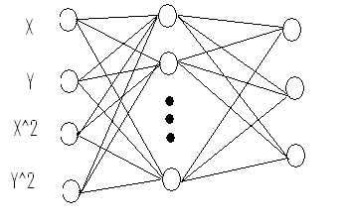
Since circles are now linear in the input space of the network it is possible to successfully separate examples one, two and three with only two nodes in the intermediate layer. However back-propagation still gets stuck at suboptimal solutions as in part C.

A.
Training Set
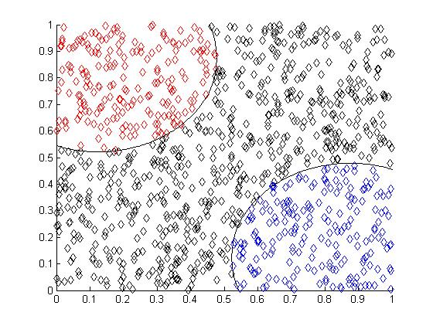

One Intermediate Node
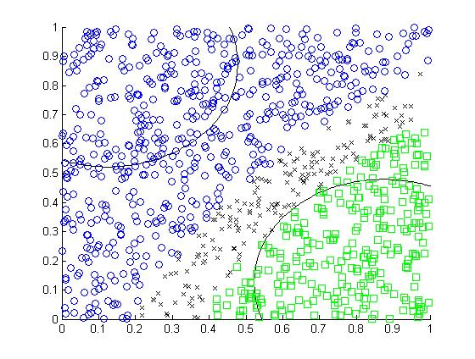
Two Intermediate Nodes
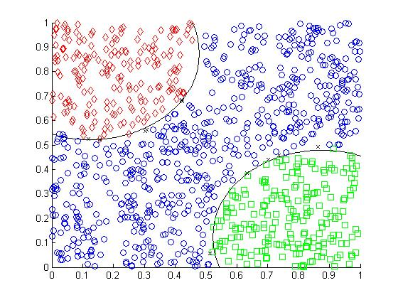

Summary Data
Intermediate Nodes | 1 | 2
Error 100,000 Iterations | 17.5846 | 6.993
Error 500,000 Iterations | 18.4253 | 4.08
Points Wrong | 264 | 4
Points Uncatagorized | 175 | 11

B.
Training Set
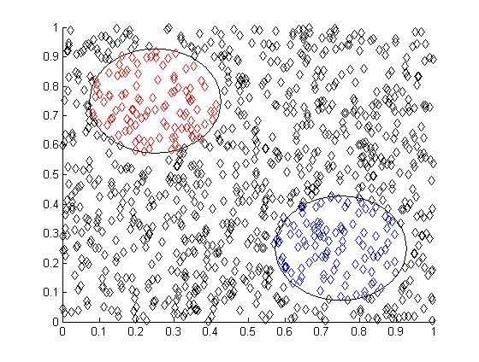
One Intermediate Node
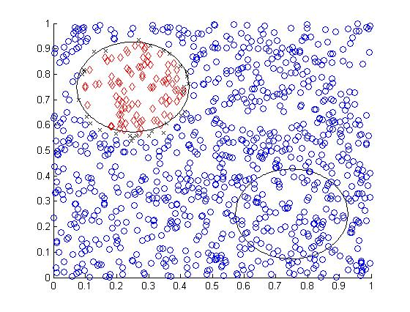
Two Intermediate Nodes
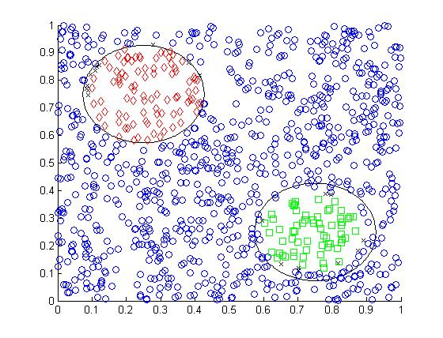
Summary Data
Intermediate Nodes | 1 | 2
Error 100,000 Iterations | 17.1714 | 15.3428
Error 500,000 Iterations | 14.1197 | 7.7818
Points Wrong | 102 | 30
Points Uncatagorized | 31 | 20

C.
Training Set
One Intermediate Node
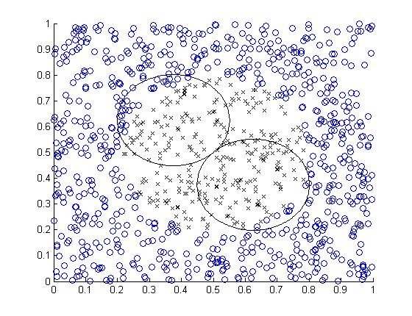

Two Intermediate Nodes
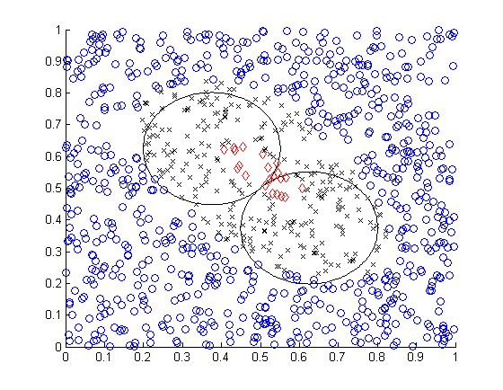

Three Intermediate Nodes
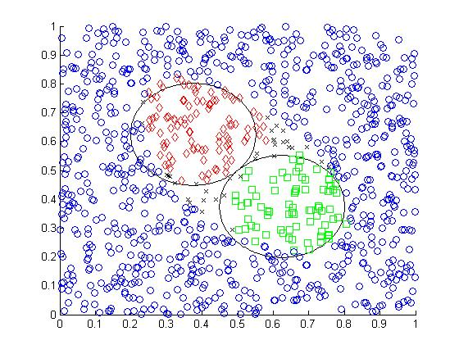
Ten Intermediate Nodes
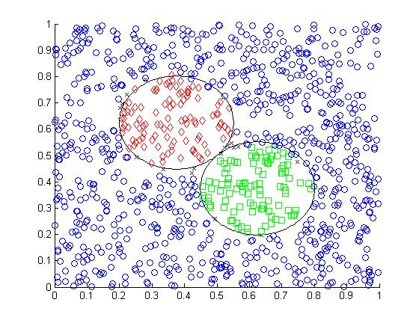
Two Intermediate Nodes – Good Start
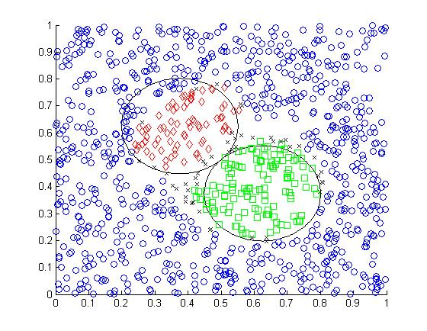

Summary Data
Intermediate Nodes | 1 | 2 | 3 | 10 | 2- good start
Error 100,000 Iterations | 15.2754 | 13.0401 | 7.7329 | 6.3342 | 11.5733
Error 500,000 Iterations | 15.2254 | 12.8589 | 7.9461 | 4.3988 | 10.0481
Points Wrong | 38 | 17 | 33 | 13 | 38
Points Uncatagorized | 290 | 267 | 30 | 17 | 48

Example Five

This example is a survey of various conceived separation problems. Parts A, B and C all use linear and squared data as input and part D uses only linear data. Parts A is really just a variation of example one except one have the subsets has a concave boundary instead of a convex one. The main point of part B is that as squaring the data is also useful if one of the boundary lines is of order higher than two. . Part C is interesting because of the way in which one of the subsets is embedded in another. Part D is an example of a disjoint subset. Although the lines are linear the fact that this worked has implies that neural networks are capable of doing such a separation. Overall example five is an illustration that many different kinds of separations are possible and that it seems neural networks are useful to approximate the separation maps.

A.
Training Set
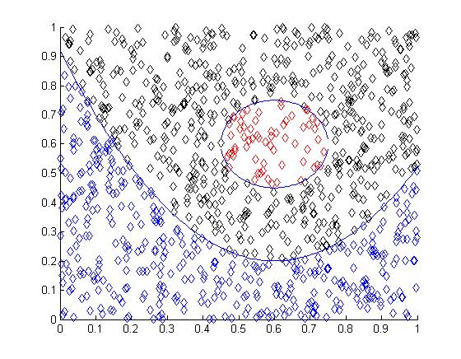
Six Intermediate Nodes
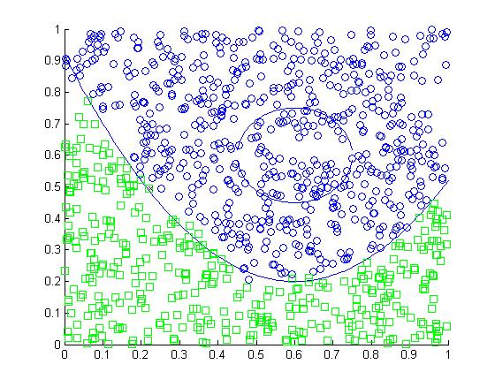
Six Intermediate Nodes – Good Start
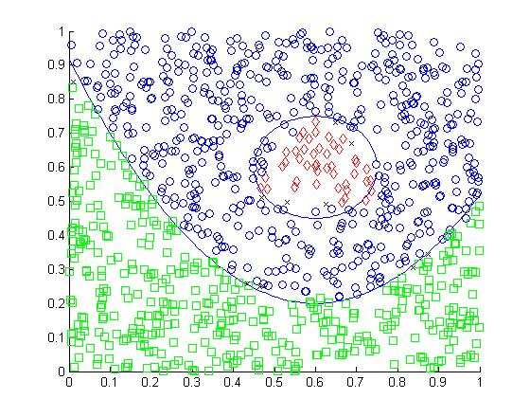

B.
Training Set
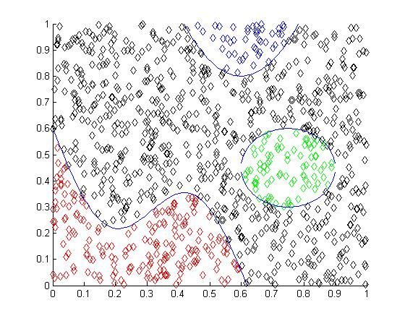
Ten Intermediate Nodes
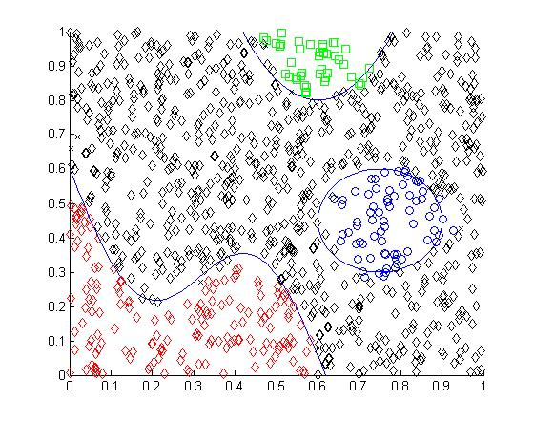
C.
Training Set
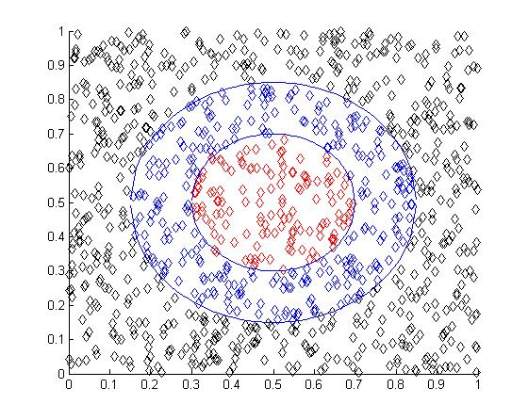

Four Intermediate Nodes
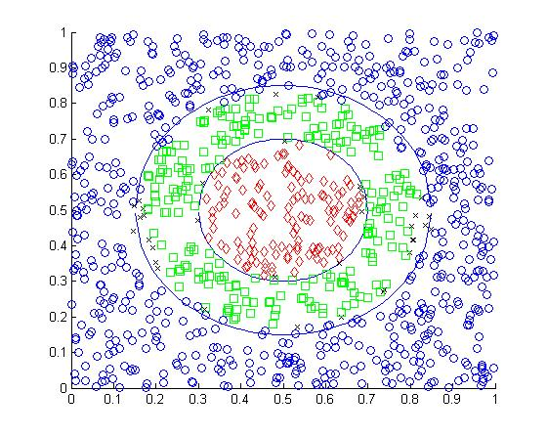
D.
Training Set
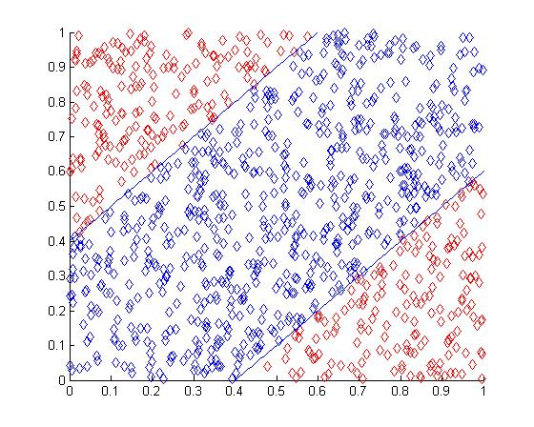
Six Intermediate Nodes
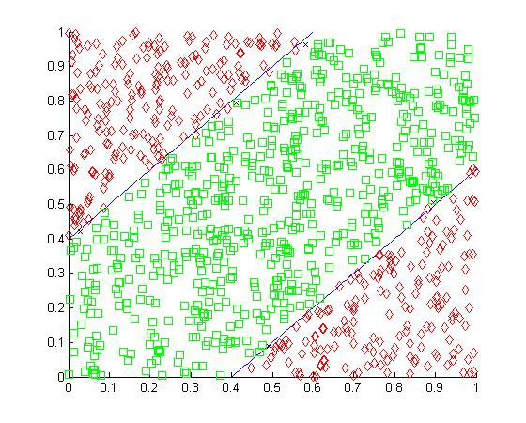

Summary Data
Problem | A | A good Start | B | C | D
Number of IntermediateNodes | 6 | 6 | 10 | 4 | 6
Error 500,000 Iterations | 10.5371 | 8.1414 | 8.7715 | 13.0256 | 4.9493
Error Million Iterations | 10.9076 | 6.3551 | 6.0153 | 9.9428 | 3.3389
Points Wrong | 71 | 22 | 31 | 23 | 8
Points Uncatagorized | 3 | 13 | 8 | 36 | 5

What is a “good start”?

Training a neural network with back-propagation to approximate a separation map often leads to suboptimal network weights which give the error function a local minimum. One way to ameliorate this is too initialize the weights of the arcs from the input nodes to the intermediate nodes so as to mimic lines or curves that roughly run along the boundaries of the subsets in the space. For example …
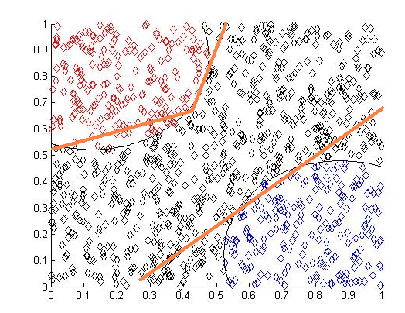
These lines are roughly:
Y1 = 0.16279 X + 0.55
Y2 = 5 X – 1.3
Y3 = -1.3 X + 0.5091

So the initial weight matrix from the input to the intermediate layer (with bias node) is
(X) (Y) (1)
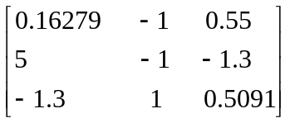

Unfortunately this can only be applied when you can see the boundaries of the subsets.

Conclusion

From examples one through five it is evident that increasing the number of intermediate nodes and transforming the data before input can both help the network approximate the separation map. One of the biggest things to recognize from the results above is that back-propagation gets stuck at local minima. This leads to networks which are capable of accurately approximation the separation map doing very poorly. In these conceived two dimensional examples it was easy to deal with that problem however in real applications it probably won’t be possible to see that data.

There are many algorithms which have been developed to perform better than standard back-propagation such as simulated annealing, back-propagation with transfer function slope updates and back-propagation with variable learning rate. But none of these methods take into account the specific problem at hand. It seems that it may be possible to design a good way to train neural networks specifically for separation problems. A fundamental characteristic of these problems is that the category subsets of the space S must all be disjoint. This fact makes it possible to train smallish neural networks to recognize the dichotomous case for each category which could be combined into a larger network for retraining.

A drawback of this project is that the all of the experimental examples used were conceived by me. This means they probably don’t look anything like any sort of real world problem. If I had more time I would really like to examine at least one real world problem that could be treated as a categorization.

